Application attacks

Cross-site scripting (XSS)

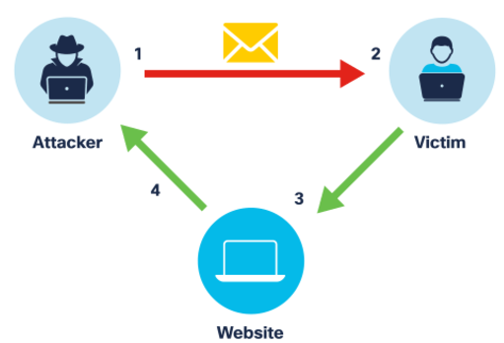

Common vulnerability found in many web applications

This is how it works:

1. Attacker exploits XSS by injecting